Lab 1 Physics

- "C:\Users\grant\Downloads\BHP Handbook.pdf"
Root=x
Directory=x
File name=x
Extension=x

- 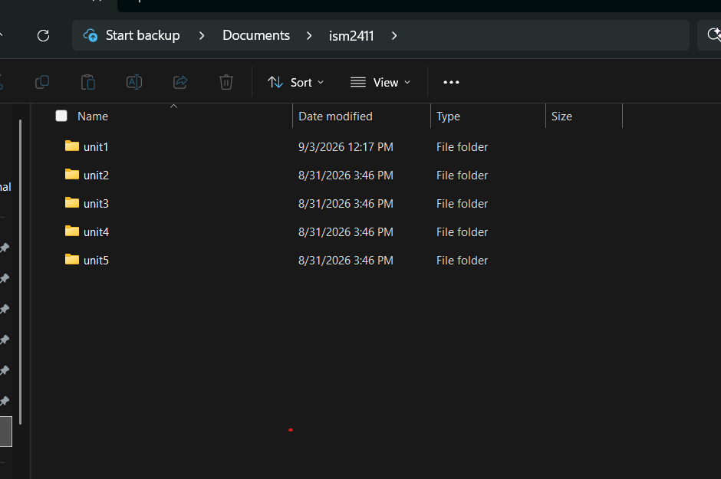

3.CPU= Cpu is the processer on your computer it does all the work and when you type something into any searchbar or app its being ran by the CPU
Ram= Short term memory, Ram is where the files on your computer are being ran, it is short term memory and resets every time you reset the computer, meaning if its not saved it disappears.
Storage = Long term memory, this is what saves when your computer is turned off, if its in storage it is able to be recalled at anytime and does not disappear
file= a digital program/ file that stores data on the computer, files are stored on ram or storage where they can be recalled
Directory= the Directory is where the file is being stored/ what area. For example if a file is from downloads it would be in the downloads directory
Path= the complete path your computer takes to find where a file is stored, the root+directory+ all the rest of the stuff that goes down till you actually find the file and where it is.
Extension= The extension is the thing at the end of a file name, being .py, .pdf., and all the rest that tells the computer what this file is and how to run it.
Program= a program is like a set of instructions given to the computer to execute. For example if I were to write a line of code in python that line of code would be a program that when run would execute what I asked.
Interpreter= Reads the program and executes it, there are many type interpreters that work for very different programing languages and without them your code will not run.

4.)Homework, emails, notes. All of these could be automated to run with a program with enough coding skill

5.) /home/alive/projects/q1_report/data/sales.csv

home
|_alice
|_projects
|_q1_report
|_data
|_sales.csv

/home/alice/projects/q1_report/scripts/summary.py
Home
|_alice
|_projects
|_q1_report
|_scripts
|_summary.py
/home/alice/projects/q2_report/data/sales.csv
Home
|_alice
|_projects
|_q2_report
|_data
|_sales.csv

6.) For each scenario below, identify whether the problem is in RAM, storage, or something else, and explain your reasoning:
(a) You edited a spreadsheet for an hour and your laptop died. When you restart, your changes are gone.
-Ram, Ram is not permant and if the computer turns off it will delete
(b) You try to open a CSV file and get an error saying the file cannot be found.
This is a different issue, as this is not an issue of being able to run the file its being able to find the file, meaning either the name was wrong, or file was deleted.
(c) Your Python script is running slowly when processing a 2 GB file.
This is a Ram issue as its running on the ram and if its going slowly it may be using up to much ram and not being able run it while running other things.

Stretch 1.)
scores = [10, 30, 20, 50, 40] “stores the 5 scores in a list”
champion = 0 “set champion score to 0”

for score in scores: “run thrus each score in list and compares it to chamion”
if score > champion: if score is > than champion replace champion with score
champion = score
print("New high score!") “print new high score”
else:
print("Not quite...") “if less print not quite”

print("Final result:") after going thru everything print final score
print(champion)

stretch 2.) 76.3 MB Ram is used.
This is very important when working with large data sets, as the more and more code you use the more Ram it uses, and you must be careful as if your code becomes to much for your Ram to handle than you can not run it. However 76 MB for 1 million lines is not as much as you think. If you ran 10 million lines of code than you are a little under 1Gb with most computers being able to use 8-16 you can run massive amounts of code without running into issues.

